

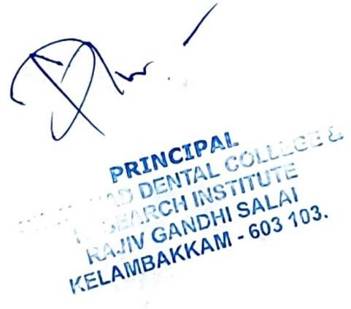

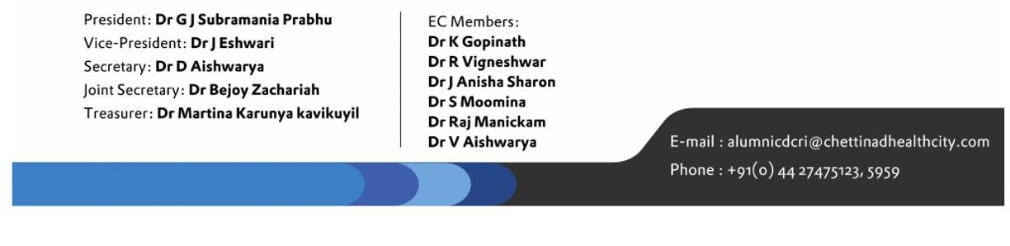

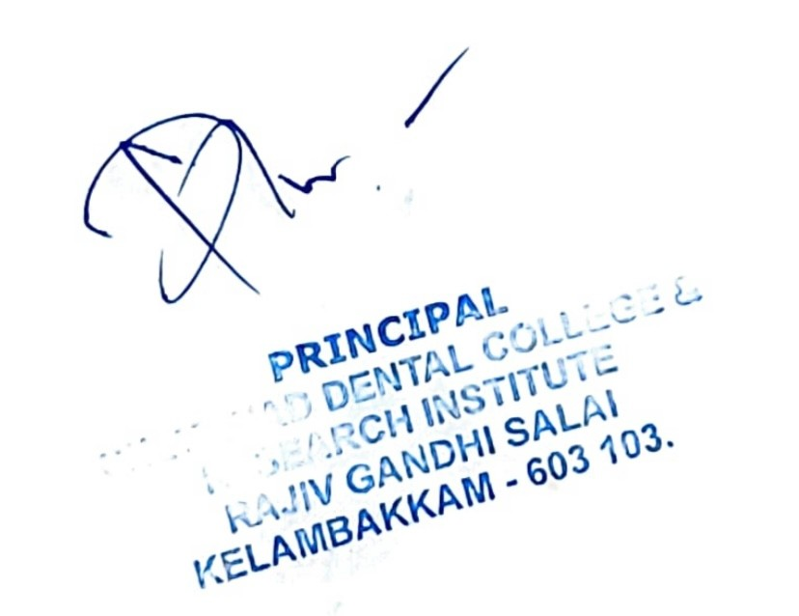

|  |  |  |  |  |  |  |
| --- | --- | --- | --- | --- | --- | --- |
| **CHETTINAD LEGENDARY ALUMNI WING - KELAMBAKKAM** | | | | | | |
| Accession Register Details 2020-21 | | | | | | |
| **S.No** | **ACC.NO** | **Title** | **Author** | **Edition** | **Publisher** | **Price** |
| 1 | GD00432 | CRANIOFACIAL SURGERY AND DISTRACTION OSTEOGENESIS | BALAJI S.M |  | BALAJI DENTAL | 1500 |
| 2 | GD00433 | TRANSACTIONS CRANIOFACIAL SURGERY AND DISTRACTION OSTEOGENESIS | BALAJI S.M |  | BALAJI DENTAL | 1500 |
| 3 | GD00434 | TRANSACTIONS CRANIOFACIAL SURGERY AND DISTRACTION OSTEOGENESIS | BALAJI S.M |  | BALAJI DENTAL | 1500 |
| 4 | GD00435 | TRANSACTIONS CRANIOFACIAL SURGERY AND DISTRACTION OSTEOGENESIS | BALAJI S.M |  | BALAJI DENTAL | 200 |
| 5 | GD00436 | TRANSACTIONS CRANIOFACIAL SURGERY AND DISTRACTION OSTEOGENESIS | BALAJI S.M |  | BALAJI DENTAL | 200 |
| 6 | GD00437 | TRANSACTIONS CRANIOFACIAL SURGERY AND DISTRACTION OSTEOGENESIS | BALAJI S.M |  | BALAJI DENTAL | 200 |
| 7 | GD00438 | TEXTBOOK OF OROFACIAL PAIN | MASTHAN KMK; BHUMINATHAN S.; ARAVINDHA BABU N. | 1 | K.M.K. MASTHAN | 200 |
| 8 | GD00439 | PREVENTIVE AND COMMUNITY  DENTISTRY CLINICAL RECORD BOOK | SHIVAKUMAR M. |  | JAYPEE | 125 |
| 9 | GD00440 | CLINICAL MANUAL FOR ORAL DIAGNOSIS | BEENA VARMA | 1 | CBS PUBLISHERS & DISTRIBUTORS | 395 |
| 10 | GD00441 | EXPERIMENTS IN MICROBIOLOGY | IMTIYAZ WANI | 1 | PV BOOKS | 355 |
| 11 | GD00442 | A TEXT BOOK OF MEDICAL MICROBIOLOGY | IMTIYAZ WANI | 1 | PV BOOKS | 575 |
| 12 | GD00443 | PROSTHODONTICS EXAM PREPARATORY MANUAL FOR UNDERGRADUATES | VIJAY PRAKASH; RUCHI GUPTA | 1 | ELSEVIER | 580 |

|  |  |  |  |  |  |  |
| --- | --- | --- | --- | --- | --- | --- |
| 13 | GD00444 | PERIODONTOLOGY EXAM PREPARATORY MANUAL OF UNDERGRADUATES | VIVEK BAINS; VIVEK GUPTA; JYOTI BANSEL | 1 | ELSEVIER | 700 |
| 14 | GD00445 | ESSENTIALS OF OPERATIVE DENTISTRY | ANAND SHERWOOD I | 1 | JAYPEE | 795 |
| 15 | GD00446 | CUNNINGHAM'S MANUAL OF PRACTICAL ANATOMY VOL-II: THORAX AND ABDOMEN | ROMANES,G.J. | 15 | OXFORD | 410 |
| 16 | GD00447 | PHARMACOLOGY AND  PHARMACOTHERAPEUTICS. VOL-2 | SATOSKAR R S;  BHANDARKAR S. D. | 10 | POPULAR PRAKASHAN | 100 |
| 17 | GD00448 | PHARMACOLOGY AND PHARMACOTHERAPEUTICS.  VOL-1 | SATOSKAR R S; BHANDARKAR S.  D. | 14 | POPULAR PRAKASHAN | 220 |
| 18 | GD00449 | PHARMACOLOGY AND PHARMACOTHERAPEUTICS.  VOL-2 | SATOSKAR R S; BHANDARKAR S.  D. | 14 | POPULAR PRAKASHAN | 220 |
| 19 | GD00450 | BASIC & CLINICAL  PHARMACOLOGY | BERTRAM  G.KATZUNG | 7 | MC GRAW HILL | 1020 |
| 20 | GD00451 | PHARMACOLOGY AND PHARMACOTHERAPEUTICS | SATOSKAR R S; BHANDARKAR S.  D. | 7 | POPULAR PRAKASHAN | 800 |
| 21 | GD00452 | PHARMACOLOGY AND PHARMACOTHERAPEUTICS | SATOSKAR R S; BHANDARKAR S.  D. | 8 | POPULAR PRAKASHAN | 100 |
| 22 | GD00453 | PHARMACOLOGY AND PHARMACOTHERAPEUTICS | SATOSKAR R S;  BHANDARKAR S. D. | 10 | POPULAR PRAKASHAN | 180 |
| 23 | GD00454 | PHARMACOLOGY AND PHARMACOTHERAPEUTICS.  VOL-1 | SATOSKAR R S; BHANDARKAR S.  D. | 13 | POPULAR PRAKASHAN | 450 |
| 24 | GD00455 | PHARMACOLOGY AND  PHARMACOTHERAPEUTICS | SATOSKAR R.S.;  ETAL.. | 16 | POPULAR  PRAKASHAN | 375 |
| 25 | GD00456 | PHARMACOLOGY AND  PHARMACOTHERAPEUTICS | SATOSKAR R.S.;  ETAL.. | 16 | POPULAR  PRAKASHAN | 375 |

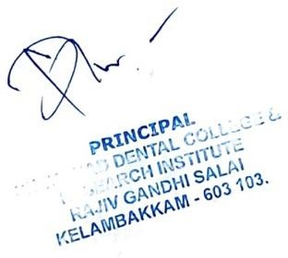



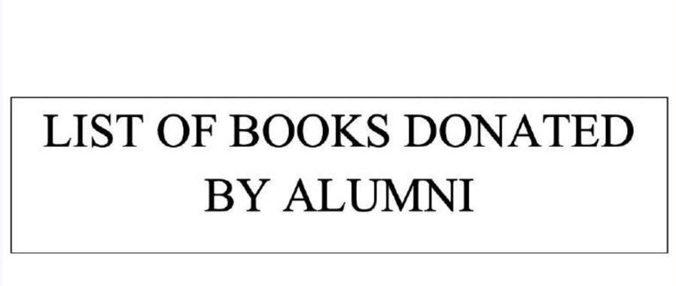

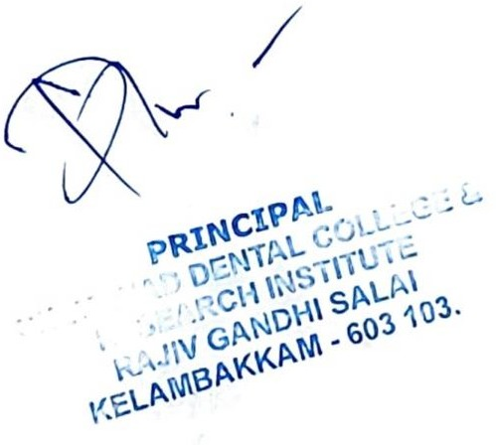





CHETTINAD LEGENDARY ALUMNI WING -KELAMBAKKAM

List of Books Donated by alumni Accession Register Details

|  |  |  |  |  |  |  |
| --- | --- | --- | --- | --- | --- | --- |
| **S.NO** | **ACC.NO** | **TITLE** | **AUTHOR** | **EDITION** | **PUBLISHER** | **ISBN** |
| 1 | GD00351 | TEXTBOOK OF GERIATRIC ORAL  PATHOLOGY | MASTHAN KMK; RAGHAVENDRA JAYESH S. | 1 | LMK | 200 |
| 2 | GD00352 | TEXTBOOK OF GERIATRIC ORAL PATHOLOGY | MASTHAN KMK; RAGHAVENDRA JAYESH S. | 1 | LMK | 200 |
| 3 | GD00353 | TEXTBOOK OF  GERIATRIC ORAL PATHOLOGY | MASTHAN KMK; RAGHAVENDRA JAYESH S. | 1 | LMK | 200 |
| 4 | GD00354 | TEXTBOOK OF OROFACIAL PAIN | MASTHAN KMK; BHUMINATHAN S.; ARAVINDHA BABU N. | 1 | LMK | 200 |
| 5 | GD00355 | TEXTBOOK OF OROFACIAL PAIN | MASTHAN KMK; BHUMINATHAN S.;  ARAVINDHA BABU N. | 1 | LMK | 200 |
| 6 | GD00356 | DENTAL MATERIALS CLINICAL  APPLICATIONS | PANKAJ DATTA | 1 | CBS PUBLISHERS & DISTRIBUTORS | 424 |
| 7 | GD00357 | DENTAL MATERIALS CLINICAL APPLICATIONS | PANKAJ DATTA | 1 | CBS PUBLISHERS & DISTRIBUTORS | 424 |
| 8 | GD00358 | TEXTBOOK OF PRECLINICAL CONSERVATIVE  DENTISTRY | NISHA GARG; AMIT GARG | 1 | JAYPEE | 525 |
| 9 | GD00359 | MATERIALS IN RESTORATIVE  DENTISTRY | ANAND SHERWOOD I | 1 | JAYPEE | 495 |
| 10 | GD00360 | PERIODONTICS REVISTED | SHALU BATHLA | 1 | JAYPEE | 895 |

|  |  |  |  |  |  |  |
| --- | --- | --- | --- | --- | --- | --- |
| 11 | GD00361 | DIAGNOSTIC ORAL MEDICINE | VENKATARAMAN B.K. | 1 | LIPPINCOT WILLIAMS AND WILKINS | 1095 |
| 12 | GD00362 | ESSENTIALS OF OPERATIVE DENTISTRY | ANAND SHERWOOD I | 1 | JAYPEE | 26 |
| 13 | GD00363 | SCULPTODONTIA  GUIDE TO TOOTH CARVING | SRIKANINATARAJAN | 1 | PARAS | 295 |
| 14 | GD00364 | SCIENCE OF DENTAL MATERIALS CLINICAL APPLICATIONS | SHAMA BHAT V.; NANDISH B.T. | 2 | CBS PUBLISHERS & DISTRIBUTORS | 580 |
| 15 | GD00365 | DENTAL MATERIALS CLINICAL  APPLICATIONS | PANKAJ DATTA | 1 | Nil | 424 |
| 16 | GD00366 | TEXTBOOK OF GERIATRIC ORAL PATHOLOGY | MASTHAN KMK; RAGHAVENDRA JAYESH S. | 1 | LMK | 200 |
| 17 | GD00367 | TEXTBOOK OF  GERIATRIC ORAL PATHOLOGY | MASTHAN KMK; RAGHAVENDRA JAYESH S. | 1 | LMK | 200 |
| 18 | GD00368 | TEXTBOOK OF GERIATRIC ORAL PATHOLOGY | MASTHAN KMK; RAGHAVENDRA JAYESH S. | 1 | LMK | 200 |
| 19 | GD00369 | TEXTBOOK OF OROFACIAL PAIN | MASTHAN KMK; BHUMINATHAN S.; ARAVINDHA BABU N. | 1 | LMK | 200 |
| 20 | GD00370 | TEXTBOOK OF OROFACIAL PAIN | MASTHAN KMK; BHUMINATHAN S.;  ARAVINDHA BABU N. | 1 | LMK | 200 |
| 21 | GD00371 | DENTAL MATERIALS CLINICAL APPLICATIONS | PANKAJ DATTA | 1 | CBS PUBLISHERS & DISTRIBUTORS | 424 |
| 22 | GD00372 | DENTAL MATERIALS CLINICAL  APPLICATIONS | PANKAJ DATTA | 1 | CBS PUBLISHERS & DISTRIBUTORS | 424 |
| 23 | GD00373 | TEXTBOOK OF PRECLINICAL | NISHA GARG; AMIT GARG | 1 | JAYPEE | 525 |



|  |  |  |  |  |  |  |
| --- | --- | --- | --- | --- | --- | --- |
|  |  | CONSERVATIVE DENTISTRY |  |  |  |  |
| 24 | GD00374 | MATERIALS IN RESTORATIVE DENTISTRY | ANAND SHERWOOD I | 1 | JAYPEE | 495 |
| 25 | GD00375 | PERIODONTICS REVISTED | SHALU BATHLA | 1 | JAYPEE | 895 |
| 26 | GD00376 | DIAGNOSTIC ORAL MEDICINE | VENKATARAMAN B.K. | 1 | LIPPINCOT  WILLIAMS AND WILKINS | 1095 |
| 27 | GD00377 | ESSENTIALS OF OPERATIVE DENTISTRY | ANAND SHERWOOD I | 1 | JAYPEE | 26 |
| 28 | GD00378 | SCULPTODONTIA GUIDE TO TOOTH CARVING | SRIKANINATARAJAN | 1 | PARAS | 295 |
| 29 | GD00379 | SCIENCE OF DENTAL MATERIALS CLINICAL  APPLICATIONS | SHAMA BHAT V.; NANDISH B.T. | 2 | CBS PUBLISHERS & DISTRIBUTORS | 580 |
| 30 | GD00380 | DENTAL MATERIALS  CLINICAL APPLICATIONS | PANKAJ DATTA | 1 | Nil | 424 |
| 31 | GD00381 | MATERIALS USED IN DENTISTRY | MAHALAXMI S. | 1 | LIPPINCOT WILLIAMS AND WILKINS | 667 |
| 32 | GD00382 | REVIEW OF PERIODONTICS QUESTION AND ANSWER  FORMAT | HANUMANT | 1 | PARAS | 0 |
| 33 | GD00383 | MATERIALS USED IN DENTISTRY | MAHALAXMI S. | 1 | LIPPINCOT WILLIAMS AND WILKINS | 667 |
| 34 | GD00384 | GROSSMAN'S ENDODONTIC PRACTICE | SURESH CHANDRA B. | 12 | LIPPINCOT WILLIAMS AND WILKINS | 700 |
| 35 | GD00385 | DENTAL ANATOMY HISTOLOGY AND  DEVELOPMENT | BHALAJHI,S.I | 3 | AMPH | 595 |



|  |  |  |  |  |  |  |
| --- | --- | --- | --- | --- | --- | --- |
| 36 | GD00386 | A TEXT BOOK OF MEDICAL BIOCHEMISTRY | RANDHAWA S.S | 1 | PEE VEE | 999 |
| 37 | GD00387 | A TEXTBOOK OF MEDICAL MICROBIOLOGY | IMTIYAZ WANI | 1 | PV BOOKS | 575 |
| 38 | GD00388 | MOUTH  DISEASES (TAMIL) | MASTHAN KMK; SATHISH  KUMAR; ARAVINDHA BABU N. | 1 | BHARATHI UNIVERSITY | 150 |
| 39 | GD00389 | BD CHAURASLA'S HUMAN ANATOMY FOR  DENTAL STUDENTS | KRISHNA GARG | 2 | CBS PUBLISHERS & DISTRIBUTORS | 519 |
| 40 | GD00390 | MASTERING THE BDS Vth YEAR | HEMANT GUPTA; MUNTAZ KHAN | 1 | JAYPEE | 999 |
| 41 | GD00391 | MATERIALS USED IN DENTISTRY | MAHALAXMI S. | 1 | LIPPINCOT WILLIAMS AND WILKINS | 667 |
| 42 | GD00392 | MATERIALS USED IN DENTISTRY | MAHALAXMI S. | 1 | LIPPINCOT WILLIAMS AND WILKINS | 667 |
| 43 | GD00393 | CRANIOFACIAL SURGERY AND DISTRACTION  OSTEOGENESIS | BALAJI S.M | 1 | AACS | 1500 |
| 44 | GD00394 | CRANIOFACIAL SURGERY AND  DISTRACTION OSTEOGENESIS | BALAJI S.M | 1 | AACS | 1500 |
| 45 | GD00395 | CRANIOFACIAL SURGERY AND DISTRACTION OSTEOGENESIS | BALAJI S.M | 1 | AACS | 1500 |
| 46 | GD00396 | CRANIOFACIAL SURGERY AND  DISTRACTION OSTEOGENESIS | BALAJI S.M | 1 | AACS | 1500 |
| 47 | GD00397 | CRANIOFACIAL SURGERY AND DISTRACTION OSTEOGENESIS | BALAJI S.M | 1 | AACS | 1500 |



|  |  |  |  |  |  |  |
| --- | --- | --- | --- | --- | --- | --- |
| 48 | GD00398 | CRANIOFACIAL SURGERY AND DISTRACTION OSTEOGENESIS | BALAJI S.M | 1 | AACS | 1500 |
| 49 | GD00399 | CRANIOFACIAL SURGERY AND  DISTRACTION OSTEOGENESIS | BALAJI S.M | 1 | AACS | 1500 |
| 50 | GD00400 | CRANIOFACIAL SURGERY AND DISTRACTION OSTEOGENESIS | BALAJI S.M | 1 | AACS | 1500 |
| 51 | GD00401 | MANAGEMENT OF CLEFT AND CRANIOFACIAL  DEFORMITIES | BALAJI S.M | 1 | 7TH BWCLPC | 1099 |
| 52 | GD00402 | MANAGEMENT OF CLEFT AND CRANIOFACIAL DEFORMITIES | BALAJI S.M | 1 | 7TH BWCLPC | 1099 |
| 53 | GD00403 | MANAGEMENT OF CLEFT AND  CRANIOFACIAL DEFORMITIES | BALAJI S.M | 1 | 7TH BWCLPC | 1099 |
| 54 | GD00404 | MANAGEMENT OF CLEFT AND CRANIOFACIAL DEFORMITIES | BALAJI S.M | 1 | 7TH BWCLPC | 1099 |
| 55 | GD00405 | MANAGEMENT OF CLEFT AND CRANIOFACIAL  DEFORMITIES | BALAJI S.M | 1 | 7TH BWCLPC | 1099 |
| 56 | GD00406 | MANAGEMENT OF CLEFT AND CRANIOFACIAL DEFORMITIES | BALAJI S.M | 1 | 7TH BWCLPC | 1099 |
| 57 | GD00407 | MANAGEMENT OF CLEFT AND CRANIOFACIAL  DEFORMITIES | BALAJI S.M | 1 | 7TH BWCLPC | 1099 |
| 58 | GD00408 | MANAGEMENT OF CLEFT AND CRANIOFACIAL DEFORMITIES | BALAJI S.M | 1 | 7TH BWCLPC | 1099 |



|  |  |  |  |  |  |  |
| --- | --- | --- | --- | --- | --- | --- |
| 59 | GD00409 | ORTHODONTICS THE ART AND SCIENCE | BALAJI S.M | 1 | ARYA | 10300 |
| 60 | GD00410 | CONTEMPORARY ORTHODONTICS | WILLIAM R.PROFFIT | 1 | MOSBY | 2151 |
| 61 | GD00411 | TEXTBOOK OF ORAL AND  MAXILLOFACIAL SURGERY | GUSTAV O.KRUGEL | 6 | JAYPEE | 14500 |
| 62 | GD00412 | TEXTBOOK OF ORAL AND MAXILLOFACIAL SURGERY | VINOD KAPOOR | 1 | ARYA | 555 |
| 63 | GD00413 | HANDBOOK OF OSTEOLOGY | AJAY BHAGAT; PODDAR S | 8 | SCIENTIFIC  BOOK COMPANY | 45 |
| 64 | GD00414 | ORBANS ORAL HISTOLOGY AND EMBRYOLOGY | BHASKAR S.N | 10 | CBS PUBLISHERS & DISTRIBUTORS | 1350 |
| 65 | GD00415 | YOUR QUESTIONS ANSWERED HYPERTENSION | IAN B WILKINSON |  | CHURCHILL | 250 |
|  |  |  |  |  | **TOTAL** | **69514** |

